

Introduction to Information Technology

Our It project

Group: FoxHound

Bach T Dao | QingKai Yi | Jingbin Yin | Yongqian Huang | Shuyuan Zhang | Houguang Ren

Contents

**Figure** **Page**

TEAM PROFILE………………………………………………………………………………………………………… 2

TOOLS………………………………………………………………………………………………………………………. 19

Project Description…………………………………………………………………………………………………… 20

Skills and Jobs…….……………………………………………………………………………………………………… 28

GROUP REFLECTION……………………………………………………………………………………………….. 30

# TEAM PROFILE

**Team name**: FoxHound

**Personal Information:**

Yongqian Huang:

My name is Yongqian Huang and my English name is Barry. My student number is s3719368. my student email is <s3719368@student.rmit.edu.au>, my personal email address is barrrr.h@gmail.com. I’m from China, I can speak both Mandarin and Cantonese. I first came to Australia in 2015 then I finished year 12 last year. Now, I’m studying information technologies in RMIT. I’m interested in PC online games and horrible movies.

Jingbin Yin:

Student number: s3549994

Nationality: Chinese

Education to date: this is the second semester for me in RMIT

Languages spoken: Chinese and English

Hobby: I am a crazy fan of online games, such as league of legends. I prefer to

play RPG game rather than FPS game. I am more enjoy to chat with others in

game.

Favorite sports: In my Chinese home, there was a swimming pool behind my

house. In my childhood, my brother and I often swam there after school.

Although the swimming pool have been closed last two years, my favorite sport

still is swimming.

QingKai Yi:

My name is QingKai Yi and my student number is s3632505, my email is <s3632505@student.rmit.edu.au>. I am an international student from North East of China. I have already spent 12 years for study , from primary school to middle school , high school and then come to Australia and study language and foundation , after that I get into RMIT university and study Information Technology . I can speak Chinese and English. I'm a fan of Warfare history , especially First and Second World War .I also like photography , taking photo of natural landscape is my favorite .

Bach T Dao:

Hello! My full name is Bach Truong Dao, student ID: s3673712. I am an international student, come from Vietnam. I was born in Hai Phong city, which is located in the North of Vietnam. I was a student of Tran Phu high school - school for the gifted, physics was my major in high school. Having finished 3 years high school, I decided to study abroad. For me, studying abroad is a big opportunity for me, and I was really looking forward to it. But my English was bad, actually it is still terrible until now and I still trying to improve my English.

I consider myself as an active person. I love sports, especially soccer and badminton. I used to join some of the sport competitions in my high school but have not received any winner price, yet. However, I am still practicing to be better. I also love music, Tropical house type. I usually listen to Kygo songs when I study, work-out, go on my way to school,...

When I moved here - Melbourne, everything was very new to me, from food, weather, language to public transport and school stuffs... I found a lot of difficulties in my daily. I have got lost at least 2 times already since I moved here and I feel terrible homesick too. However, I am living with my 2 cousins, they help me a lot with starting a new life here. My 2 cousins also studied IT, one chose RMIT, the other chose Swinbourne, and they are now working as a programmer for big company now. I always look up to my 2 cousins, try my best to be like them in the future.

HouGuang REN:

My name is Houguang Ren and my student number is s3538336. My email address is <s3538336@student.rmit.edu.au>. As a Chinese student, I can speak both of Mandarin and English fluently. Currently, I am studying at Monash College before RMIT University. I like swimming which is my only hobby and favourite sport so far. Furthermore, I have a cat which is British shorthair and I love him very much.

Shuyuan ZHANG:

My Name: SHUYUAN ZHANG (Simon)

Student Number: 3632704

Email Address: <s3632704@student.rmit.edu.au>

Nationality: Chinese

Education: Finished Year11 in Ivanhoe Grammar School, Then Finished Foundation Studies in Rmit Training, And Study Bachelor of information technology in Rmit University now.

Language Spoken: Cantonese, Mandarin, English

My Hobbies: Playing Badminton, Programming , Computer games , billiards

Pet : Golden Retriever

**Team Profile:**

**Yongqian Huang:**

INTJ

Introvert (6%)   intuitive (7%)  Thinking(6%)  Judging(28%)

You have slight preference of Introversion over Extraversion (6%)

You have slight preference of Intuition over Sensing (7%)

You have slight preference of Thinking over Feeling (6%)

You have moderate preference of Judging over Perceiving (28%)

Result of My learning style:

Auditory: 40%

Visual: 45%

Tactile: 15%

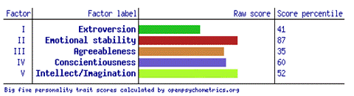

Result of five big personality tests:

Those result means that what kind of person I am and what position is suitable for me. My learning style is tended to visual, so I might use more visual material to learn things in the future. The result points out that I’m not a very extrovert person so I might work quietly as a member in a team. However, the result of Myer-Biggs test shows that I have moderate preference of Judging over Perceiving, so I might good at analysing for my team.  If I’m forming a team I will be a good worker and I can do analysis for my team mates.

**Bach T DAO:**

Result of MBTI test

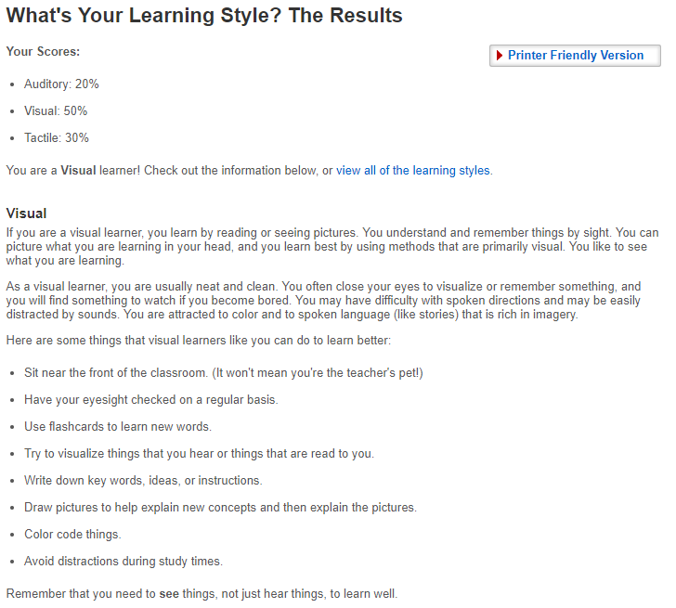**[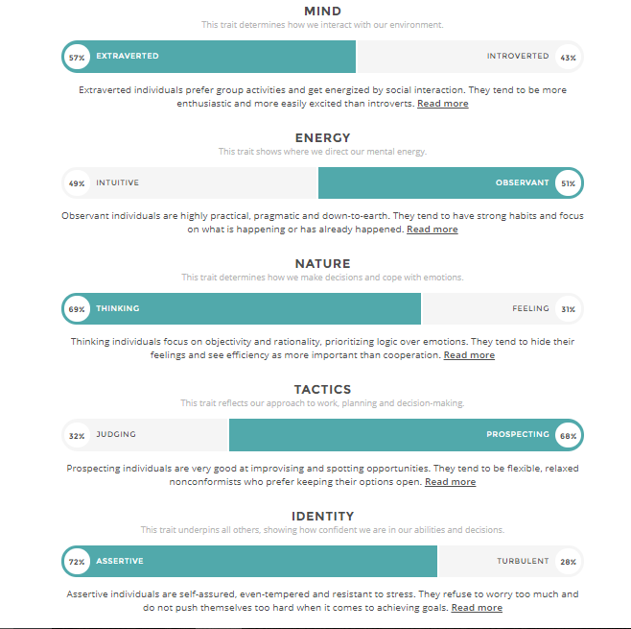](http://foxhound69.s3-website-ap-southeast-2.amazonaws.com/my%20website/Personal%20Profile.html)**

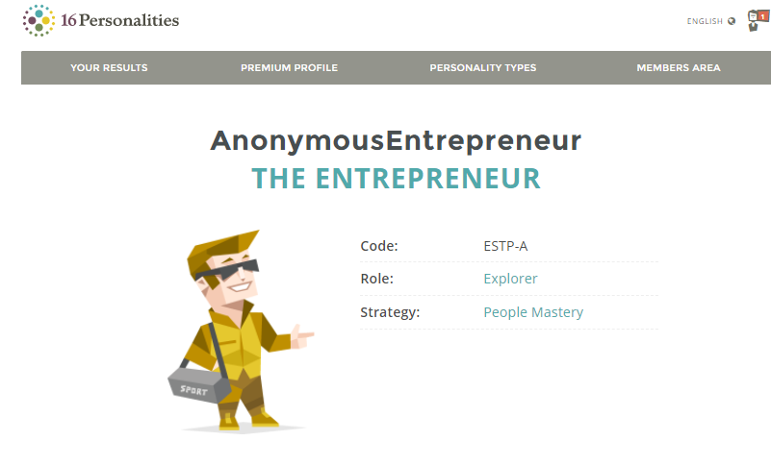

Result of addtional test (Spychometrics Project test)

Extroversion : 45   
Emotional stability : 81   
Agreeableness : 35   
Conscientiousness: 31   
Intellect/Imagination : 8

What do the results of these tests mean for you?

As I can see, I like group activities, I believe in practical things rather than imagination. I can control emotion very well, and I usually get lost in mind when walking in nature. Moreover, I am very flexible in bringing out the ideas, I always keep my options open. Because I can control my emotion so that I can be relax even in stressful situation.  
I hate boring thing, the best way for me to learn is see thing by myself and memorize it. When I forget anything, firstly I imagine the situation for that and try to get back to that time. I easily get distracted when I am studying, as a result, I need a quiet place to study.

How should you take this into account when forming a team?

Yes, definitely I will take this into account. By doing these tests, I was getting to know myself better, and I could know what I can do best. So when I do things as a team, I will have my options open, and learn from the others.

How do you think these results may influence your behaviour in a team?

These results tell me that I can learn from the others, an I can co-operate very well as a team. Hopefully, when I participate in a team in real life, I will do my best so my team can get the best results.

**QingKaiYi:**

This is my Myers-Briggs test result

Personality type: "The Mediator"

Individual traits:

                Introverted---68%,

            Intuitive---63%,

                  Feeling---68%,

                 Prospecting---64%,

                  Turbulent---58%,

Role: Diplomat

Strategy : Constant Improvement

This is my learning style test result

                  Auditory: 25%

                  Visual: 45%

                  Tactile: 30%

                  You are a Visual learner!

This is my Big Five Personality Test result

                 Openness 71%

                 Conscientiousness 52%

                  Extraversion 48%

                  Agreeableness 75%

                  Neuroticism 54%

These results mean a lot for me , they show me what is my weakness and what is my strong point and also they give me some encourage . From these results , I know that I can let my group more energetic and coadjutant. The team spirit of my group will reach the top level . When forming a team, I will try to make best use of my advantages and bypass the disadvantages to make my team running well.

**Shuyuan Zhang:**

Online test 16 Personalities: [https://www.16personalities.com](https://www.16personalities.com/)

Result link: <https://www.16personalities.com/profiles/1131827919de3>

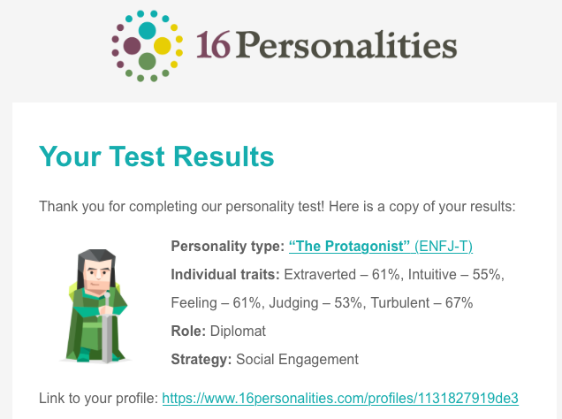

**Online test Education Planner:**[**http://www.educationplanner.org/students/self-assessments/learning-styles-quiz.shtml**](http://www.educationplanner.org/students/self-assessments/learning-styles-quiz.shtml)

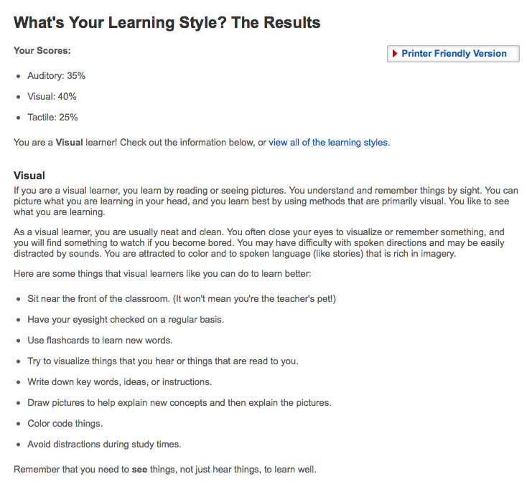

Online test: TEST MY CREATIVITY :[**http://www.testmycreativity.com**](http://www.testmycreativity.com/)

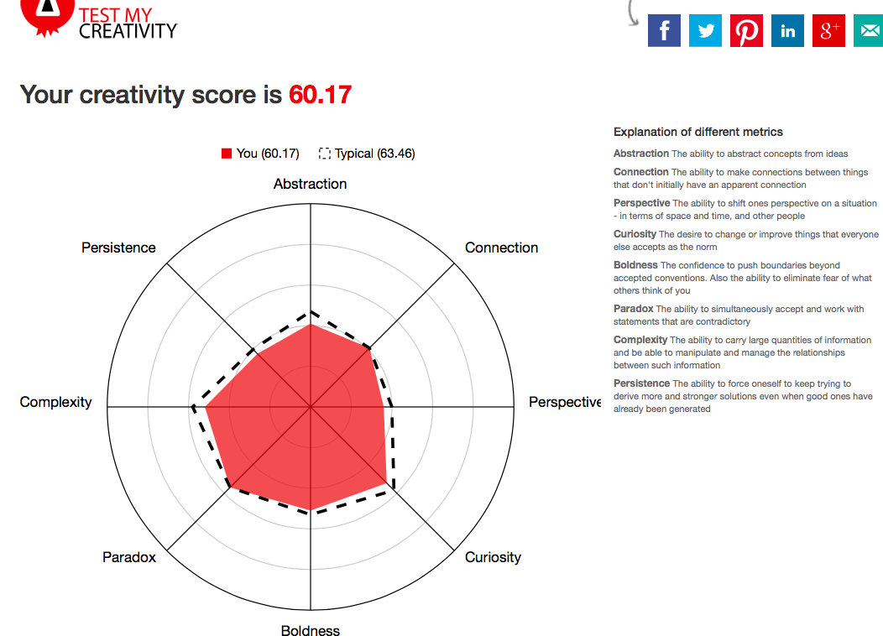

What do the result of these tests mean for me?

My Personalities online test result is extraverted-61%, Intuitive-55%, feeling-61%,Judging-53%,Turbulent-67%.  After the test, This result tells me that I am a sleek person with unique judgment and communication skills. I can walk in various social situations. My result of leaner style test is  Visual learner. That means I am more suitable to learn through reading or pictures .My creativity score is only 60.17, It is little bit low, I think I need to improve my imagination.  In the past, my understanding of myself had always been superficial. I have not conducted a profound, comprehensive, and unified thinking, and I am still not very familiar with my character. After these tests, let me have a deep understanding of my character, can better plan for future study, and have a wonderful guiding role in future study and employment..

How do I think these results may influence my behaviour in a team?

I think these tests are not very accurate and can only play a psychologically suggestive role.  These results have little effect on my behaviour in the team. I am of course pleased that the result is superior, and I will do better. If the measured result is not reliable, I will correct my behaviour.

How should I take this into account when forming a team?

I am a person who is good at communication，I think I can get along quickly with the team members. When I do things many times, I rely on my feelings and I am not stable enough. So I need to find a calm team member to stop me from making mistakes when necessary. Through the test results, find similar personality members or complementary members. I can find the person who has the same hobby and do the project together. Make sure we can learn from each other’s need in the same project.

**Houguang Ren:**

**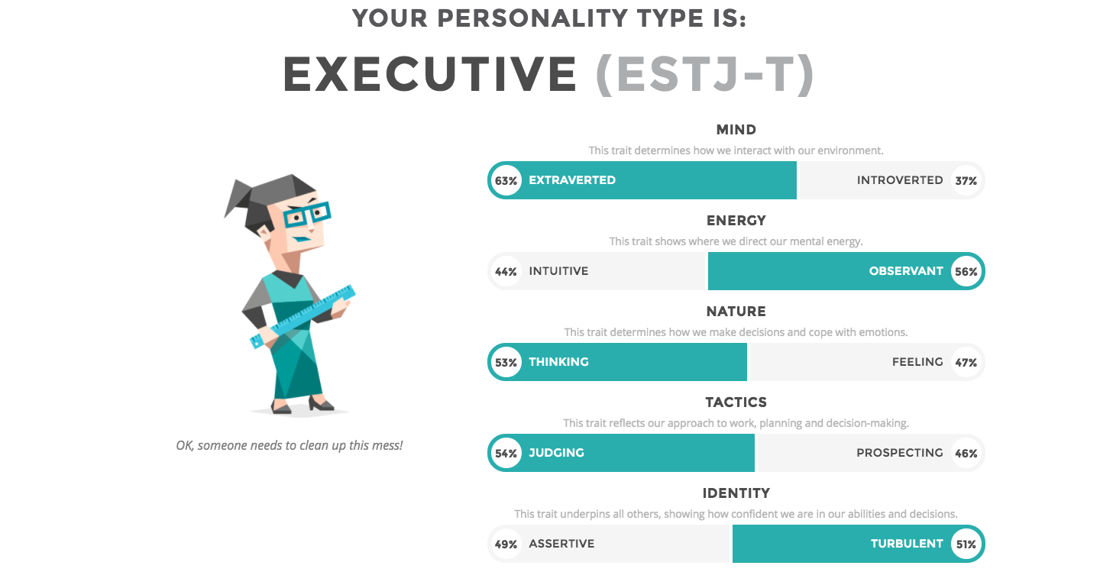 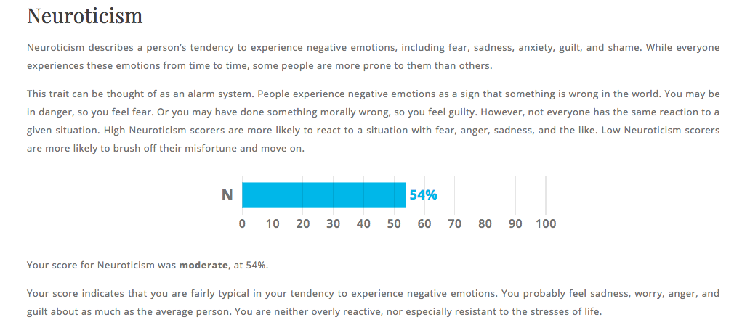 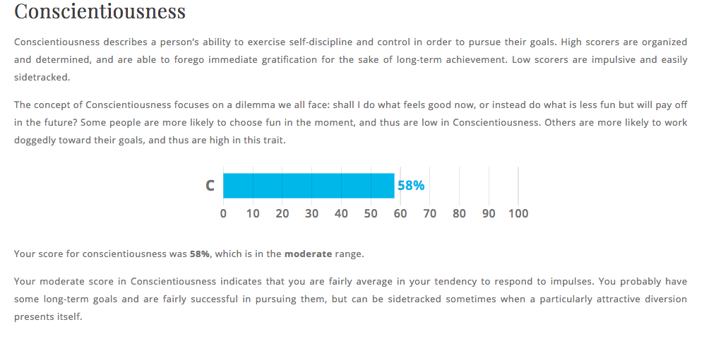 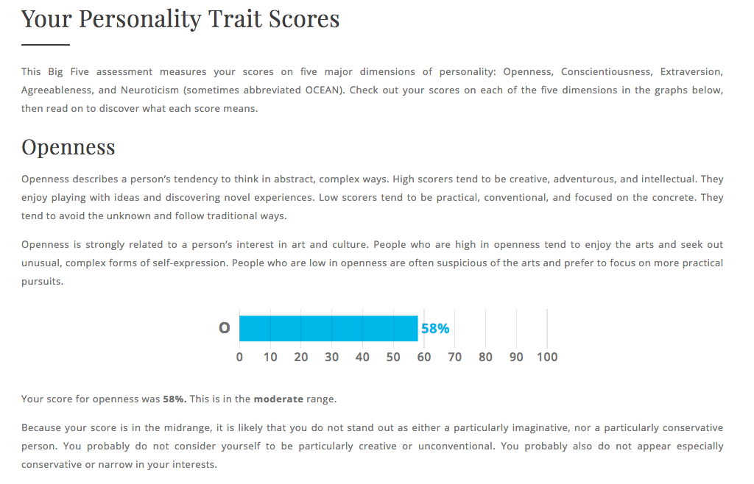 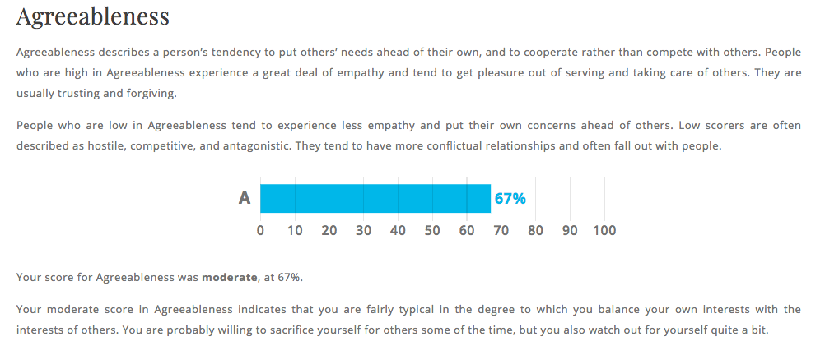 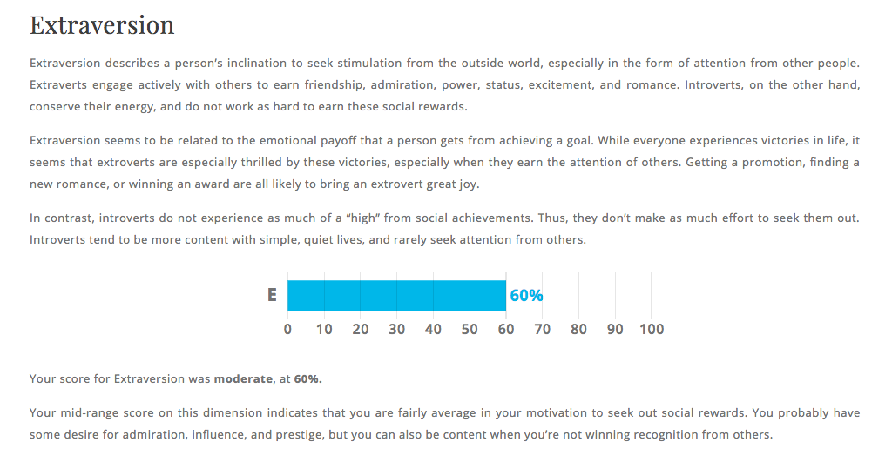 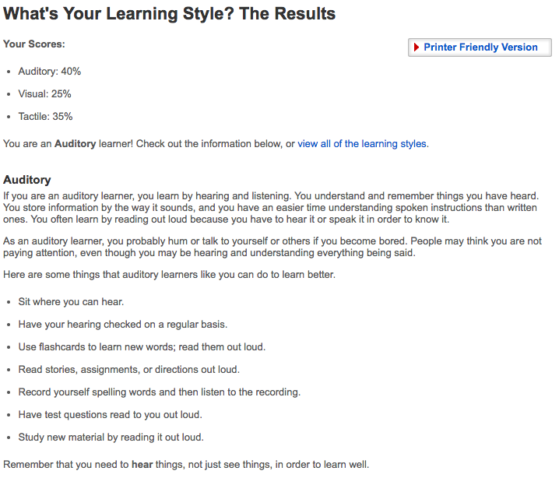**

 The results of these tests will allow me to recognize myself more clearly. Nonetheless, these tests cannot be completely relied upon. I should properly use these test results to identify my own deficiencies and then correct them. Through the results, I realise that I should strengthen my social skills.These results may affect my social behaviour in the team. According to the results, I know that I am socially weak. Thus, I will try to social with others more within the team.While forming a team, I should look for people who are good at socializing. As the team is a group cooperation, better social cooperation capabilities can make it easier for others to understand the ideas. With no doubt, the ability of individuals to solve problems is of great importance because if one cannot even complete his/her own work, there will be no more exchanges and cooperation. On the other hand, management ability is also very significant. A person with strong managerial ability can make a team operate more orderly.

**Jingbin Yin:**

The results of an online Myers-Briggs test:

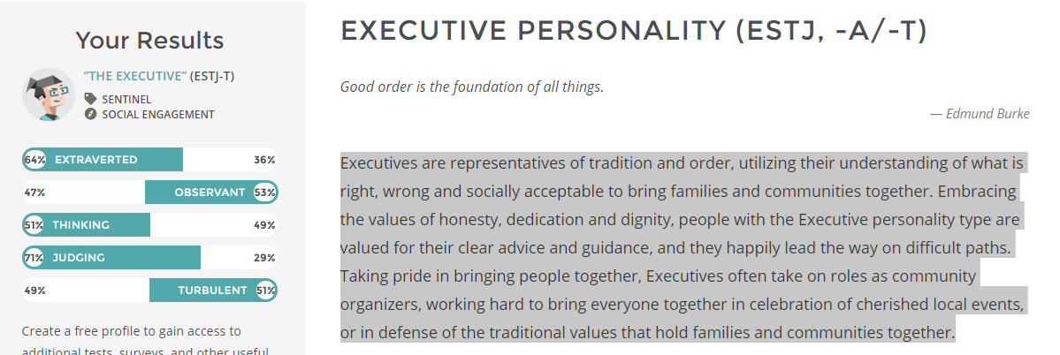

The results of an online learning style test:



**The results of a Big Five Personality test:**

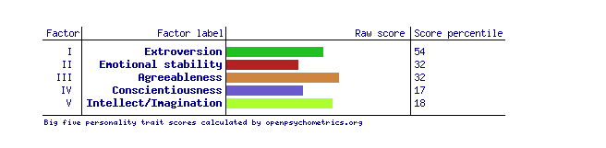

These three online test show the personality of me, let me know myself clear. The Myers-Briggs test tell me what roles should I take in the team, the learning style test tell me how could I study better and faster. In the Myers-Briggs test, the result show that I could be a good organizers in the community. And the result of the learning style test show that I am a visual learner. That means the things I saw should be remember better than other ways. In the future studying, I could try to use picture to remember the study materials.

Base on the result of Myers-Briggs test, I should be the organizers in the team. For the programming team, I think I could be the leader to plan somethings.

When forming a team, we should find some person which have the similar learning style. Because we could get the information quickly by the same way. Also, we choose a person which have an outstanding leadership to be a leader.

## Ideal Jobs:

It is actually still very equivocal because we just started to study Information Technology and most of us have no plan in the near future, yet. But in general, most of the members are looking forward to get a good job in the future as a software, applicant, game developer. Some of the common aspects that we all looking for are high salary, chance to get experiences, to learn about new thing while working and to work as a team. However, some want to start up their own company which focus on Information technology skill in the future.

## TOOLS

Link to group’s website: <http://foxhound69.s3-website-ap-southeast-2.amazonaws.com/>

The link to group’s Git repository: <https://github.com/FoxHound69/FoxHound69>

We divided the assignment to different sessions for each of the member in our group to do specific tasks. With the help of Github, it is very easy to control our project. Every members in the group know how to use Github, push and pull functions and whenever a task finishes, it will be displayed on Github so everyone can check and edit it.

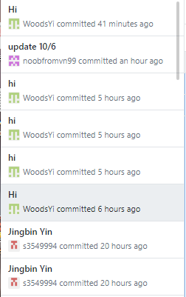

Project Description

# Overview

**Topic**

Drone express delivery of packages through unmanned low-altitude air vehicles operated by radio remote control devices and self-provided program control devices is automatically delivered to the destination. Its advantages lie in solving distribution problems in remote areas, improving distribution efficiency, and reducing Labor costs. Drone delivery not only drastically reduces distribution costs, but also increases efficiency and solves distribution problems in remote areas. At present, companies including Amazon and DHL are testing many drone distribution shipments. Drones used for business testing are mainly quadrotor or onto-wing type. The flying height is less than 1,000 meters. The flying radius is about 10 kilometers and the load are within 10 kilograms. The drone is very suitable for the delivery of remote areas and emergency items and can effectively improve the distribution efficiency and reduce manpower and transport costs. It integrates a variety of high-precision sensors such as triaxle accelerometers, triaxle gyroscopes, magnetometers, barometric altimeters, and advanced control algorithms. The drone is equipped with a black box to record status information. And it will use the GPS autonomous navigation mode to fly.

**Motivation**

With the development of artificial intelligence and other technologies, the future technological disadvantages will be further compensated. From manned operations to remote operations to autonomous flights, the transportation of future drones will become more frequent. At the same time, with the upgrade of energy storage technology, the endurance capacity and load capacity will be further enhanced, and the use of Drone in the future will further expand.

In remote areas, the volume of deliveries is small, the distance is far away, and the cost is high. Moreover, the logistics cost is mainly in the distribution link of the last mile. The data shows that in 2016, the global logistics cost is nearly 80 billion US dollars, of which the last one-kilometer transport accounts for the proportion of the total cost. 50%. Therefore, express logistics companies have enough internal driving forces to reduce costs and increase efficiency.

**a. The shortest straight-line distance**

Drone has a straight line in the air, the shortest distance, almost ignoring the terrain, there is no traditional express delivery route limitations. In the case of DHL's transport in the German towns, the air transport restrictions have more freedom than traditional methods. Take China Post as an example in the pilot project in Anji County, Zhejiang Province. It takes 40 minutes from Hangzhou Hang Zhen to Qi guan Village by car to deliver parts and it takes only 15 minutes to open the drone route. Therefore, the advantage of drones ignoring terrain is even more pronounced in remote areas.

**b. Lower operating costs:**

Relatively low cost, saving manpower and time costs. According to a study by New York financial research firm Ark-invest, Amazon's delivery service can reduce the cost of delivering small parcels to only about $1. In contrast, Amazon uses conventional delivery services in New York and other cities within one hour. The cost of each delivery is up to 7.99 US dollars.

**c. High efficiency and speed:**

At present, the mainstream speed of drones in the logistics industry ranges from tens of kilometers to hundreds of kilometers per hour. Taking DHL as an example, the third generation of multi-rotor Drone PARCELCOPTER has reached 70km/h. Moreover, Drones have expanded the efficiency of space use (from flat to three-dimensional) without risk of traffic jams. Therefore, no aircraft will greatly increase distribution efficiency.

**d. Suitable for small batch, high frequency transport:**

According to Amazon statistics, about 85% of express items are lighter than 5 pounds (about 2.27Kg), which means that many items can be delivered without aircraft. According to the data from the State Post Office, the total number of courier shipments in 2017 will reach 36 billion, and the Institute expects the number of per capita parts to reach 26. Therefore, small batches and high frequency are the key features of express logistics. Compared with other distribution methods, drones have unique advantages in efficiency and cost.

**e. Ideal for delivery in remote areas and emergency items:**

Disregarding the advantages of terrain, it can fully reach the distribution needs of remote mountainous regions. China Post opened the first drone distribution route in the Andizhan Village area of Zhejiang Province and piloted remote regional distribution services. DHL uses drones to deliver medicines to customers who live on the island, and like Amazon Prime Air's launch of 30 minutes, it also gives full play to the speed of drones and provides customers with more time-efficient delivery. service.

**Landscape**

DJI drone technology is very mature. Leading position in the world. DJI drones can be used for reference. The main competitor is Amazon Prime Air. Amazon drones can be delivered within 30 minutes from order placement to delivery. It is an important part of Amazon's future e-commerce logistics. Amazon Prime Air is currently mainly used in the suburbs, can cover some rural areas, and plans to deliver goods in urban areas in the future, so that drones can put parcels on the roof. However, the prerequisite for completing the distribution within 30 minutes is that drones can fly 15 miles. The obvious fact is that not all the customer's designated delivery locations are within 7.5 miles of Amazon's warehouse. You can't expect the drone to be ready at all, just wait for the customer to load the package to the customer's home immediately after completing the payment. There are too many preconditions for the delivery of drones, and Amazon has not announced any response in these areas. Drone transport projects can carry greater weight and more transit time than Amazon drones. On the other hand, drone projects are more intelligent.

Detailed Description

Aims

As time goes on, technology makes our life more convenient. Our project “delivery drone” is targeted to create a more convenient service for people -- “Drone Delivery”.

During this assignment, our group aim to try a real drone. We aim to buy a small drone which can move under our control. This is the first step of letting our project. Next, if we finish our aim early, we are targeting to install a GPS feature on our drone.

As the result of researching China market which has a relativity perfect delivery system, We found that one of the reason makes China delivery service cheap is the labor. Our Drone delivery project can replace the high labor in Australia. In order to reduce the fees of maintenance, we decide to make the delivery drone more durable by selecting fit material . One of our goals to provide a cheap service for customers.

We aim for ‘5 minuets delivery’. Melbourne’s canteen has a low intensity outside of the city, so in many situation customer need to wait for an hour to get their food. And in now day, drone has a high speed up to 65km/hour. We intend to set our drones delivery under 15 minuets in a suburb. Our target is to provide a faster service for customers.

In our conclusion, we aim to make the delivery service cheaper and quicker.

Plans and Progress

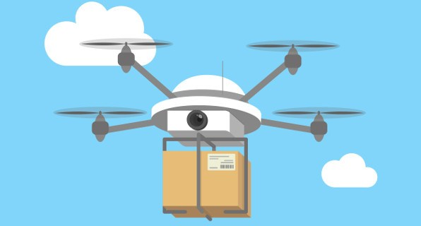

Nowadays, people tend to stay at home to order things online, however, they have to wait for very long time because the delivery depends on postal delivery. Even in the weekdays could take about 2 days to deliver in local areas, or more than 1 weeks to deliver oversea. Moreover, postal delivery by human does not works during weekends and holidays. In order to reduce human labor and the time taken to ship things, our group (FoxHound) came out with an idea of replacing with robot labor. At first, we thought of something like a truck that programmed to be automatically delivery things by using google map. So the truck doesn’t need human to control, just for maintenance and programming codes for it. However, it seems to be very expensive to do this and more likely to cause accident on the road. Therefore, we have decided to choose some sorts of flying things to deliver items, and the drone could be the best options with the lowest risks and price when it is partially small and it can fly in the air.

To do this, we plan for the future with these front-end use:

* User application: This is for tracking the drone, know where to pick up item, set time, send feedback… So these are just some basic functions we could think of for the app/website and in the future we will add more.
* Business application: register to use service, maintenance, tracking drone, set location, path… Basically, for business user, application/website is to register to use Transport Drone service, they can transfer money monthly, annually to third party to use it.

As well as the back-end: So there will be Drones which specially support delivery, and a team to maintain it to run, control all of the risks. There will be technical and programming team to run this.

We are also looking forward to use this system worldwide. Currently, a drone can only fly within a small area on average due to its limited power. There could be two options for this:

* Make the drone bigger, which include bigger battery, or can use fuel or gas to fly as a real transport.
* As a battery, there are some specific charging stations everywhere so the drone can stop somewhere and recharge its power supply.

There are also some problems must be concerned when making the drone transportable. First importance thing is navigation system; our group idea is using google map system. Basically, before delivery, there will be path set up in the google map, and the drone will be programmed to know exactly the direction it should follow. And navigation system needs to have some sort of scanner, detection in order to avoid obstacles, risks, hazards when flying. Second thing is security and stable operation, which is very important for one delivery system to work well. The reason for this is the drone transport all alone and there will be more likely to become a target to thief, robbery. We think of attach the drone with camera, to track everything surrounding and report problems to the operate station which is held by the business. In addition, we also want to make the drone to be able to withstand bad weather conditions such as rain, windy, or even a storm. But it seems like very difficult so electrical insulation, waterproof would be enough for now. Last but not least, safety must be the most important thing to work on, problems like how to avoid crashing and cause injury to pedestrian is very vital. But even human delivery is far more dangerous when there is an accident, to individual himself or to someone else.

So far so good, until now, we come up with clear plan ahead with what to do and what job for everyone. The only thing we need to achieve is knowledge and time. Therefore, nothing is impossible, we can successfully finish our project and make it be practical in some days.

Roles

There are 2 main position for this project idea: programmer and technician.

Bach Truong Dao, Yongqian Huang: Programmer

Jingbin Yin: User Interface Designer

QingKai Yi, Shuyuan ZHANG, HouGuang REN: Technician

We can also hire someone for positions in order to finish this project.

Scope and Limits

In the limit time, our project will force on setting up the mockup .The mockup will record the information of merchant (e.g the opening hours, location, product, price) which is available on our app. And do the order system to calculate the price of the users ordered and the estimated delivery time. Also, these information should be send to the merchant. These information will let them know when the drone will reach their restaurant and what should they need to prepare.

If there is more free time after the last part is done, the GPS will be set up on one drone and test it .To do these, the control system will be created and it will return the signal to our application. And then this information will be send to users, let users know where the food they ordered is.

Tools and Technologies

The transport drone uses an eight-rotor aircraft equipped with a GPS auto-control navigation system, an GPS receiver, various sensors, and a wireless signal transmitter and receiver. The UAV has various flight modes such as GPS auto-navigation, fixed-point suspension, and manual control. The transport drones can carry packages through unmanned low-altitude aircraft operated by radio remote controls and self-contained program control devices. It can also be automatically delivered to the destination. The drone also has a loss of control protection function. When the drone enters an out of control state, it will automatically maintain accurate hovering and search for empty lands in the vicinity to wait for collection. UAVs transmit data through 4G networks and radio communication remote sensing technologies and dispatch center and self-service courier cabinets, send their own geographical coordinates and status information to the dispatch center in real time, receive instructions from the dispatch center, and receive the destination coordinates. Later, it will use the GPS autonomous navigation mode to fly. After entering the target area, it sends a landing request, a local mission report, and a local operating status report to the destination courier. After receiving the landing request response, the courier guides the drone in the express cabinet. Top landing platform landing, loading and unloading courier, and rapid charging. The drone will fly to the express delivery distribution point after losing contact with the dispatch center or experiencing an abnormal failure. Moreover, the position of the drone is connected to the recipient's mobile phone, and the recipient can check the position of the drone at any time. When the weather changes abruptly, the drone has a sensor that senses it and will return home quickly to wait for the next instruction. This prevents accidents happening.

Testing and Timeframe

In 2015, Russia's Copter Express partnered with fast-food chain Dodo Pizza to launch a drone pizza delivery service. The drone can reach speeds of up to 40Km/h and can carry objects up to 5 kilograms at one time. The machine is equipped with a GPS global positioning system and camera so that the control center can keep track of its position. According to CopterExpress, they are the first companies in the world to provide drone delivery services. Prior to this, they had used small drones to deliver small parcels. Dodo Pizza promised to use a drone to deliver pizza, guarantee delivery within half hour, if the customer wait more than one hour, diners can eat by free . In June of 2015, Domino's Pizza Company in the United States also tested drone delivery service.

,In China, the food delivery company “hungry?” started the drone mode in ShangHai. Their operating model is :

1.The takeaway brother will deliver the customer's meals to the distribution point of drone transport.

2. The drone loaded with meals took off to the destination collection point.

3.Flight is completed automatically by the program plus manual operations.

4. Meals slowly land at the destination hub.

5. The delivery boy who is responsible for the delivery has already waited at the distribution point.

6. The takeaway brother remove the meal and send it to the customer.

7. After each flight, drones need to replace the batteries.

In the entire meal delivery session, drones accounted for about 70% of the total flight distance, but businesses and users could not see drones at all.

Furthermore, Uber participates in the delivery of drone meal delivery service and promises to deliver it within 5 to 30 minutes on May 14, 2018 .

More and more companies are participating in drone food delivery projects. Drone meal delivery services will become a trend in the next five years. For diners, in addition to speed, there is one more important point is not need to tip.

Risks

As a digital devices, it surely will be some risks, the first and the most that people cared is about drone hacking, it is true that maybe the drone will be hacked and will be used to do some illegal activities , maybe hackers will use them to hurt some people or invade other people’s privacy , we will do some actions to protect our system just like what other worldwide company did . Also the drone maybe will crash when it deliver the goods , the goods will be broken , maybe even the people will be hurt . To minimize this probability , we need to monitor the drones’ condition all the time , we will try to improve the drones’ emergency response measures , our first idea for now is airbag in drones , when there comes the height’s sudden drop , the monitor system will detect that and do emergency response measures , the airbag will open and protect the drones and also goods .

Group processes and communications

In conclusion, our group has a good communication with each other, we did meet each other once a week. Because of the final exam is close to this assignment, we reduce times of face-to-face meeting. However, we still meet each other three times face-to-face outside the class time in order to discuss our work. We use ‘WeChat’ to contact each other online. And we share our files by using Github and Email. In case to avoid losing contact with group members, we have each others’ phone number and we can call each other anytime we need.

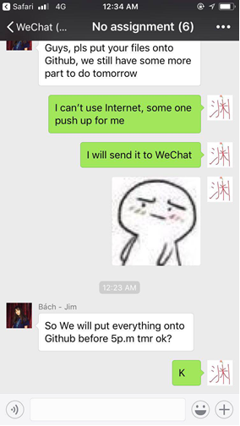

Skills and Jobs

There are four position should be employed for the project:

1. Solutions Architect

2. Test Analyst

3. System Administrator

4. .net Engineer

**The first position (Solutions Architect)**

For the first position (Solutions Architect), it is a position which is look like a team leader of the project. Solutions Architect should list the task, split the work done and give the planning for the group. Also this position should give the solution when the other meet the problem. Usually, Solutions Architect have to know well of the marketing and understand what the product client want to get is. In conclusion, Solutions Architect will be the leader for the project, which is look like the manager in the group.

Skill needed:

1. well know in one program language such as java,c#

2. master in database, Mysql/oracle

3. outstanding communication skill (for take order from client and spilt work to engineer)

4. enough experience as a programmer

**The second position (Test Analyst)**

That is easy to understand what should be done by Test Analyst. It is the position who need to find out the bug and report to the Engineer and make sure there is no error will be appear when user is using. Usually, when programmer of the group finish their part, they will send it to test Analyst. And the bug finding process will be start. If there is not any problem, it could be add to the project.

Skill needed:

1. well know in one program language such as java,c#

2. master in finding bug and bug fixing skill

3. patience and carefully

**The third position (System Administrator)**

This is a position which is focus on maintain the computer system and the hardware. SA should responsibility for security and documenting the configuration of the system. Because our project is belong to express industry. That is pretty important to protect the information of user. So that SA is the necessary position of our group.

Skill needed:

1. well know as keep security of the computer system

2. master in hardware fixing

**The fourth position (.net Engineer)**

This is the position who is force on design and program the application for the user. Engineer will be get the work split from the Solutions Architect. And try to code the program which is going to meet the task need. This is the most basic and important position of the group.

1. Professional to use .net

2. Enough teamwork

Group Reflection

Team: FoxHound 6/10/2018

We have six group members in this group, everyone is active during this assignment, everyone keeps working hard and no one think about quitting and we do care about it, we decided to finish this assignment by everyone taking one part as usual and we just finish our project idea from assignment 2 , we tried to make our dream come true , though there are still some technical issues , but our blue print came out finally .

**Bach’s reflection:**

So, everything went smoothly when we were working together. Same as assignment 2, we divided the work equally and everyone was happy to do this. However, we also need to concentrate on the exams so it was really difficult for us to prepare for the project. As a result, there is still a limited functions and progress. But, I believe our project idea is a good one and in the future if we have a chance to work together, maybe we can make it happens.

Summary of my work:

* Plan and progress
* Tools
* Roles
* Fixing issues of final file

**Yongqian’s Reflection:**

I have done progress and communication , and plan the aim and goals . This is a short reflection because we follow our project idea from Assignment 2 . In summary, regarding to our group’s pleasant atmosphere and high effectiveness, we are happy to work together.

**Shuyuan’s Reflection:**

From my personal point of view, I think everyone in group Foxhound all did a good job on what they were assigned with. I did the Testing and timeframe part for my group. Everyone in our group has got an equal task and everyone is willing to take on the tasks what they assigned with.

Each of us helps each other. When someone has any doubts about the task, someone immediately stand out to answers it. We trust each other and we all finish the task on the stipulated date and deliver it to the person who finalized the task. In conclusion, I am really honored to join this group Foxhound. Everyone is kind and helpful when needed. Through this assignment, It’s not only increased my opinion of IT, but also made me acquainted with this group of friends.

**QingKai’s Reflection:**

My job is tools and technology , risks , I do like to think about risks that out project will have , there are many risks that we need to care about and I pick two of the most dangerous risks . Also I did the words fix work and I put our great works together , this is how the final file came out .

**Houguang’s Reflection:**

Everyone has chosen what they want to accomplish. In terms of project ideas, we discussed together with the good idea. The advantage of doing so is that it can gather everyone's opinions and prevent problems that are not considered due to lack of personal experience. In the group meeting, we talked about our own ideas. Finally, after everyone's discussion, we integrated the ideas of everyone. Everyone in the meeting is actively asking questions and then working together to solve them. Everyone helps each other and solves problems. During the discussion, everyone can also actively put forward various ideas. At the same time, I also successfully completed my part, and my team members also gave me a lot of help on project ideas. At the same time, when we do not have a group meeting but there are problems that need to be discussed. We will use WeChat to solve the problem online. As we work, we will urge each other to complete the work. I am very honored to be able to join this group. We are all very happy to work together and hope to have the opportunity to continue working together.

**Jingbin’s Reflection:**

In these semester, we done two assignment together (A2 and A3). I am happy to work with my teammate. We discuss the problem together and always we could find out the solutions very soon. Everyone are nice and friendly, we have a nice planning to split up the work. That is pretty sure about the work we done are nearly equal. However, there is still a problem in our group. We could finish the job on time, but it always will be the last minutes of the deadline. We have a wonderful work split planning, but we are not good at time planning.

Summary work done by myself:

1. Scope and limit of the project

2. Skill and jobs

3. Testing and bug fixing process